Local Government Association EU Circular Economy position paper

April 2015

Executive summary

The Local Government Association (LGA) is the voice of English local government. Our mission is to help support, promote and improve local authorities in England.

A circular economy makes best use of waste and resources, which is a high priority for English local authorities as key delivery agents for municipal waste collection, reuse, recycling and disposal services. These are the most recognised service councils offer making them a key doorstep issue for householders.

We welcome the review of the original EU circular economy package and offer a range of suggestions to inform the revised proposals. Our suggestions seek a more rounded approach that includes all waste produced across the economy, a greater focus on waste prevention that builds on councils’ commitment to the principles of the waste hierarchy and avoiding the disposal of waste to landfill.

Reductions in existing and future English local authority budgets and the opportunity to advance the polluter pays principle necessitates a rebalancing of responsibilities. Achieving a more circular economy will only be possible if there is a more equitable contribution by those at the top of the supply chain to supplement the current reliance on those collecting and disposing of material at tax payer expense once it enters the waste stream.

We are calling for revised circular economy proposals that:

- ensure that circular economy ambitions don’t result in increased burdens on tax payers through targets that are achievable, avoid undermining committed infrastructure investments, and apply as broadly as possible to all circular economy participants rather than relying on a default tax payer contribution;

- set a minimum level of responsibility for producers towards achieving a more circular economy. To better enshrine the ‘polluter pays’ principle through requiring a minimum 50 per cent producer contribution by 2025 and a full cost contribution to the costs of waste collection and disposal by 2030;

- design out waste by setting out expectations on product design for greater waste prevention, reuse and recycling through an overarching suite of product specific targets delivered though a broadened Ecodesign Directive;

- drive demand for secondary materials and improve the financial viability of recycling collection through product and material specific requirements to use recycled content in product manufacture.
Explanatory memorandum

- Context

Revising the circular economy proposals provides the opportunity to update existing EU legislation on waste and resources, which to date has been predominantly focussed on material that has entered the waste stream. There are clear benefits from achieving a more circular economy, including greater competitiveness for the EU from increasing the value obtained from the existing resources in the economy. A more circular economy would also offer increased employment potential with estimates suggesting that it could help create more than 200,000 additional jobs in the UK by 2030.

Household waste collected by local authorities makes up only a small proportion (14%) of the total amount of UK waste, with the vast majority coming from commercial sources. Councils are currently directly involved in working towards two EU targets – on landfill and recycling. The UK is firmly on course to exceed its landfill targets as a result of the extensive efforts of local authorities. This has seen a radical reduction in landfill per household by 78 per cent since 2002/3 (see Annex for details), brought about through the delivery of a range of waste treatment infrastructure by councils up and down the country.

The recycling target has seen similar levels of commitment from English local authorities with recycling collections now the norm for almost all homes across England, which has delivered a 400 per cent increase in recycling levels since 2000. However, despite this improvement the UK is not yet on track to meet the 50 per cent target in 2020. To do so will require further changes and a significant increase in investment at a time of reducing central and local government budgets.

The LGA is working with local authorities to focus on actions and opportunities to help meet the existing recycling target and to help achieve this we are presenting a range of proposals to the UK government. These will use the position we set out in two previous publications - Wealth from Waste and Routes to Reuse. These reports inform this submission and seek a change in the terms of the debate on waste and resources to maximise the potential of the waste and resources sector to generate jobs and growth and reduce the burden on tax payers.

- Circular economy proposal themes

Revising the original circular economy proposals offers an opportunity to take a more holistic view of what is needed to ensure greater resource efficiency. This will naturally include a focus on the material captured from households and businesses as waste. English local authorities are ambitious to continue to improve and develop their services based on what they can deliver locally, but there is a limit to what can be achieved by the collectors of waste alone. The real opportunity, following the principles of the waste hierarchy, is to influence the amount and nature of material long before it reaches the waste stream and in some cases before it even exists at all.

The EU proposals should provide long term certainty about the role of all, not just publicly funded, participants in the circular economy. The focus should be on measures that encourage innovation in product design and shaping a stronger market for reuse and recycling to support new, more efficient processes. There is scope for the proposals to combine increased resource efficiency and security with a reduction in the burden on tax payers while also obtaining the associated benefits of increased value and jobs in the green economy.

The following themes provide suggestions on how this could be achieved (see the annex for a summary of our suggestions against the waste hierarchy).

- Decoupling circular economy ambition from additional tax payer burden
The pursuit of existing EU waste targets since 2000 has required a doubling of spend by English local authorities to £3.28 billion. This makes collection and disposal of waste and recycling the third highest cost service for English local authorities. Our estimates show that current spending on waste by English authorities would need to increase significantly to include additional collection services (in particular organic waste) just to meet the existing 50 per cent target. This will be unachievable since councils are under extreme pressures to reduce spending in response to a 40 per cent reduction in government grant to English local authorities since 2010, a level of reduction that is projected to be repeated over the next parliamentary period to 2020.

English local authorities will continue to drive improvement in collection of waste and recycling, not least because English householders so value the service they receive, on which they report consistently high satisfaction levels. This will continue to involve further evolution of service that reduces landfill and collects more material for reuse and recycling as efficiently as possible. However, increased levels of ambition in recycling performance will become progressively more expensive to achieve above the existing target level, and will be increasingly difficult for tax payers to bear. The initially proposed incremental ban on landfilling would also be challenging to achieve and will imply additional costs for material that cannot be cost effectively recycled, unless accompanied by corresponding producer contributions.

There are also practical limitations on what can be realistically achieved. English local authorities have committed many hundreds of millions of pounds to underpin the delivery of waste treatment infrastructure to radically reduce landfill by 2020. This treatment capacity will process a volume of waste that will make meeting a suggested 70 per cent recycling target unachievable. Unless Member States’ committed investments are taken into account in target setting there is a risk that these expensive and long term facilities are made redundant leaving public authorities with large liabilities.

Achieving the EU ambition for a more circular economy will require action to reduce the burden on tax payers. The revised proposals should recognise that additional top down targets and landfill bans will not be affordable if meeting them, or liabilities associated with them, requires additional funding by tax payers. The focus should therefore be on intervention and associated targets that require all circular economy participants to contribute to greater resource efficiency.

The EU proposals should be ambitious in seeking a more circular economy that achieves greater resource efficiency and the benefit of additional jobs in the green economy. However, proposals should be affordable and care taken to minimise the reliance on targets on member states that will predominantly be met through tax payer funded intervention. Where targets are necessary they should be achievable, avoid undermining committed infrastructure investments, allow realistic lead times and apply as broadly as possible to all circular economy participants.

- Minimum levels of participation by all circular economy actors
The existing EU waste legislation rightly follows the principles of subsidiarity and places responsibility for achieving targets with member states. In most cases member states have found it difficult to share that responsibility sufficiently across their supply chains given a wish to avoid disadvantaging businesses that have transnational interests. It is therefore understandable that most member states have focussed on the waste stream and for the majority of associated costs to be borne by tax payers. However, as the level of ambition increases the benefits of the circular economy and higher levels of resource efficiency will be increasingly difficult to achieve through activity in the waste stream at the ‘end of pipe’ alone.

The inclusion of extended producer responsibility conditions in the original circular economy proposals was a positive step, and should be included in the revised proposals to ensure all member states have comprehensive schemes. This will be particularly important for the UK, which raises the lowest level of contribution from producers amongst all EU member states at less than 20 Euro per tonne of material compared to 200 Euro in Austria and over 150 Euro in France and Spain. To further illustrate this the UK’s limited packaging producer compliance scheme generated £111 million of compliance revenue in 2013, only £37 million of which went towards collection. This compares to the £550 million cost to local authorities for collection and sorting of packaging material.

Clearly scheme design should be the responsibility of the member state, but across the EU there is a consistently high proportion of the burden of meeting waste targets carried by tax payers as opposed to producers of packaging and other waste streams.

The ‘polluter pays’ principle invests responsibility for dealing with the cost of disposal of a product with the producer (and by association the consumer). Where the majority of these costs are routinely paid by the tax payer there will be insufficient incentive for the producer to design and manufacture a product that minimises the cost of disposal. To address this we suggest that firm direction is provided at the EU level to require all member states to establish or improve producer responsibility regimes that raise the full cost of collecting and sorting material put on the market by producers. Action at the EU level should provide long term certainty and ensure a minimum level of consistency across member states, so that a level playing field is established for businesses across Europe.

To enshrine the ‘polluter pays’ principle and better share of responsibility for the cost of achieving a more circular economy, the EU should establish a minimum level of producer contribution based on the costs of collection and subsequent reuse, recycling or disposal of their products. This should be sufficiently ambitious and work towards, via a series of stages, at least 50 per cent of cost by 2025 and full contribution to costs by 2030. This would allow the EU to demonstrate its ambition to achieve the benefits of the circular economy and would formally bind producers into its principles while better balancing costs with tax payers.

- Designing out waste
At present a large proportion of material that finds its way into the waste stream cannot be cost effectively reused or recycled. While innovative techniques continue to be developed to disassemble, refurbish, repair and recycle different products it can be challenging to create financially viable markets for secondary resources across all materials and product types. This can be exacerbated where there has been insufficient interest at the product design and manufacture stage to make reuse and recycling economic. The market for recycled plastic demonstrates the challenge of increasing resource efficiency. Recycling plastic is largely only financially viable in relation to plastic bottles made of PET or HDPE. Recycling other plastics is at best financially marginal and in cases where a product combines plastics with other materials the prospect of viable recycling will be limited.

Equally, there are many products that have very limited scope for reuse, cost effective refurbishment or disassembly for component reuse or recycling. For example waste electrical and electronic equipment (WEEE) can have some of the higher values of material in the waste stream and provide significant potential for reuse. However, in 2012 only 9 per cent of the household WEEE collected through producer compliance arrangements in England was reused, while 200,000 tonnes was disposed of in residual waste costing tax payers millions of pounds. Estimates suggest that 77 per cent of WEEE disposed of at English local authority household waste and recycling centres is not able to be to be reused, due to a product being either beyond or too costly to repair. Achieving a significant increase in reuse and refurbishment of WEEE will require new business models and a commitment to design products that have greater longevity and are cost effective to repair and refurbish.

Achieving greater resource efficiency should be a shared responsibility between the designer, manufacturer, consumer and reuser/ recycler. Investing the vast majority of responsibility at material collector level ignores the potential for innovation in design and material use to realise savings in effort, cost and minimisation of waste once a product has entered the waste stream.

While it should not be the role of EU to specify exactly how each product sold in the EU market is designed and manufactured, there is an opportunity for the EU to align existing legislation by developing strategic principles on product design. These should use the principles of the waste hierarchy to ensure waste is minimised at the end of life and more material can be cost effectively reused or recycled. The realisation of such an approach would significantly reduce waste, its associated cost, and boost EU based refurbishment and remanufacturing industries and the jobs they provide.

The EU should use the circular economy proposals to set out its expectations on product design for greater waste prevention, resource efficiency, reuse and recycling. This could be achieved through an overarching suite of product specific targets that bring together existing legislation. Implementation could be achieved through a broadened Ecodesign Directive within its 2015-17 workplan with an expectation that scheme design and monitoring is carried out at member state level.

- Driving demand
Intervention designed to create a more circular economy should balance supply with demand side measures to help create a self-sustaining market for secondary material streams. The current EU Packaging Directive targets require the recycling of particular materials, but make no requirements for the use of recycled material in product manufacture. This gap means, as is currently seen across the EU, that secondary material reprocessors have to compete in a volatile market that is often undermined by lower cost virgin materials.

UK plastics reprocessors, for example, have been experiencing severe difficulties as a result of the recent oil price slump which has made virgin plastic cheaper than the recycled product. If this leads to closure of important UK reprocessing facilities it will remove a proportion of the UK plastic reprocessing capacity, which will lead to job losses and a reduced domestic market for recycling plastic bottles collected by local authorities. This is likely to increase overseas export, which would run counter to the EU proximity principle in terms of waste treatment as close to source as possible. It would also lower the value of collected plastic undermining the business case for its collection.

A focus on resource efficiency needs long term certainty and viable markets for secondary materials to attract and maintain investment. The manufacture of many products already make use of significant but varying proportions of recycled content such as glass, paper, some plastics and various metals. A commitment to increase resource efficiency and reduce reliance on primary material extraction will need to build in demand to overcome short term material price volatility. This could be achieved by ensuring that a minimum amount of recycled content is used in product manufacture. Specifically this could start with key materials commonly used in product manufacture. This would help to increase the certainty of demand and help to support secondary material value, which would in turn help to underpin the financial viability of collection, sorting and reprocessing.

Procurement policy can also drive demand. If coupled with improvements in product design it can help a more mature market for reused, refurbished and recycled products to develop. Such a market would also help to support the price and collection of end of life cycle products. However, procurement policy can support many considerations such as social responsibility; fair trade and ethical issues; public health, innovation; support for SMEs; fostering public-private partnerships, or support for community organisations etc. Along with environmental ambitions all these goals can be taken into consideration in addition to price and ensuring the best use of tax payers’ money. Given the range of goals that can be influenced by procurement policy care should be taken to avoid binding requirements on public authorities that would significantly increase costs for tax payers. The EU must not therefore mandate the use of any one of these public procurement criteria in isolation making it more important than the others.

Decisions on the policy goals to be achieved by each public contract, and the balance between them, must be left to democratically elected local authorities, as outlined in the new EU public procurement Directive (2014/24). An alternative to binding procurement proposals to support the circular economy would be for the EU to facilitate the development of a market in reused, refurbished and recycled products through design requirements as outlined above and encouraging public authorities through good practice and guidance on procurement strategies.

To drive demand for secondary materials and improve the financial viability of recycling collection the EU should develop product and material specific requirements to use recycled content in product manufacture. A phased recycled content requirement for European manufacturers and those wishing to access the European market would help to support the price of secondary materials, better offset collection costs and secure a vibrant market in material reprocessing helping to support and sustain EU member states’ green economies. Green procurement can also help to support demand, but should not establish binding requirements on public authorities and increased costs to tax payers at the same time as excluding other important issues.

Annex
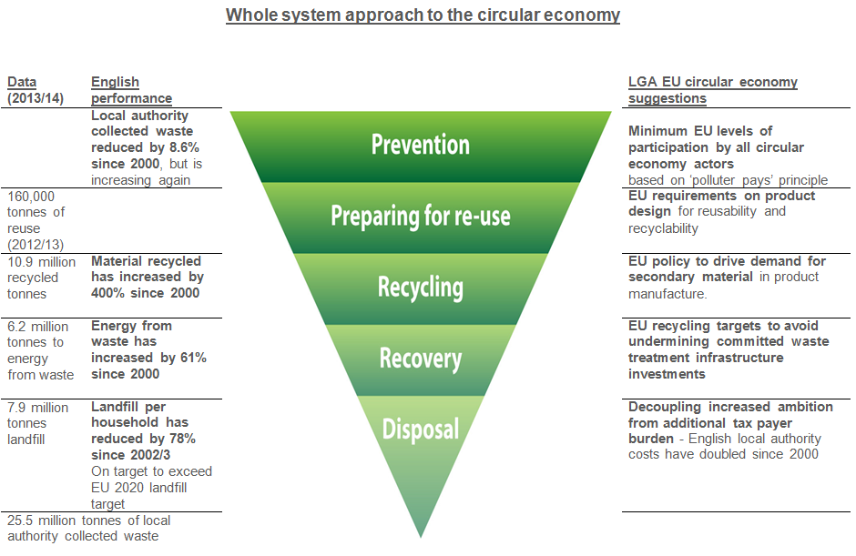

WRAP and Green Alliance study: Employment and the Circular Economy – Job creation in a more resource efficient Britain
The percentage of household waste recycling in 2003/04 was 17.8 per cent and in 2013/14 it was 43.5 per cent
Wealth from Waste report: http://www.local.gov.uk/c/document_library/get_file?uuid=a9ae477e-e0cf-4665-862e-ed01caa810f6&groupId=10180
Routes to Reuse report: http://www.local.gov.uk/documents/10180/5854661/LGA+Routes+to+Reuse+FINAL+FINAL.PDF/5edd19ba-7c13-47c5-b019-97a352846863
Total for waste and recycling collection and disposal 2013/14
LGA Future Funding Outlook 2014 http://www.local.gov.uk/documents/10180/5854661/L14-340+Future+funding+-+initial+draft.pdf/1854420d-1ce0-49c5-8515-062dccca2c70
LGA resident tracker shows 83 per cent of residents were very or fairly satisfied with their waste collection (Oct 2014) http://www.local.gov.uk/documents/10180/11719/October+2014+Resident+Satisfaction+Polling+-+Final+Report.pdf/dd57f664-443f-4bf7-9455-4506614bee6c
Eunomia 7th Residual Waste Infrastructure Review shows that committed waste treatment infrastructure in the UK when operational will mean that the maximum achievable recycling rate would be 66 per cent.
European Commission report: Development of Guidance on Extended Producer Responsibility (EPR), Final Report 2014
National Packaging Waste Database
LGA Wealth from Waste report http://www.local.gov.uk/c/document_library/get_file?uuid=a9ae477e-e0cf-4665-862e-ed01caa810f6&groupId=10180
WRAP estimates from ‘Realising the Value of Household WEEE’ calculated for England minus WEEE reused through the WEEE compliance scheme in 2012.
WRAP ‘Realising the Reuse Value of Household WEEE’ estimates that up to 23 per cent of WEEE disposed of at household waste and recycling centres has potential to be reused (calculated for England minus WEEE reused through the WEEE compliance scheme in 2012). The report also states that 78 per cent of broken WEEE is either broken beyond repair or too costly to repair.
For example Eco Plastics in Hemswell went into administration in 2014 and Closed Loop Recycling in London issued a statement in March 2015 that the drop in oil prices may cause it to go into administration

